RESTAURANT RATING PREDICTION USING MACHINE LEARNING
Project Report

1. PROJECT OVERVIEW
Restaurant Rating Prediction is a Machine Learning project developed using the Zomato Bangalore Restaurants dataset.
The objective of this project is to predict restaurant ratings based on different restaurant characteristics such as online ordering, table booking, number of votes, location, restaurant type, cuisines, and approximate cost for two people.
A Random Forest Regression algorithm was used to train the model and predict restaurant ratings.

2. OBJECTIVE
The main objectives of this project are:
• To analyze restaurant-related data.
• To clean and preprocess the dataset.
• To understand patterns and relationships in restaurant ratings.
• To build a Machine Learning model for rating prediction.
• To evaluate the performance of the model.
• To compare actual ratings with predicted ratings.
• To provide restaurant-level insights using visualizations.

3. DATASET
Dataset Name:
Zomato Bangalore Restaurants Dataset
Dataset Source:
Kaggle
Dataset Link:
https://www.kaggle.com/datasets/himanshupoddar/zomato-bangalore-restaurants
Important columns used in this project include:
• name – Restaurant name
• online_order – Availability of online ordering
• book_table – Availability of table booking
• rate – Restaurant rating
• votes – Number of votes received
• location – Restaurant location
• rest_type – Type of restaurant
• cuisines – Types of cuisines offered
• approx_cost(for two people) – Approximate cost for two people

4. TECHNOLOGIES USED
Programming Language:
Python
Development Environment:
Jupyter Notebook
Libraries Used:
• Pandas
• NumPy
• Matplotlib
• Seaborn
• Scikit-learn

Machine Learning Algorithm:
Random Forest Regressor

5. DATA PREPROCESSING
The dataset required preprocessing before applying Machine Learning.

5.1 Rating Cleaning
The original rating values were stored in formats such as:

4.1/5
3.8/5
4.5/5

The "/5" part was removed and the ratings were converted into numerical values.
Rows with missing restaurant ratings were removed because the rating was the target variable.

5.2 Cost Cleaning
The approximate cost column contained values with commas.
For example:
1,200
These values were cleaned and converted into numerical format.

5.3 Missing Values
Missing values in numerical columns were handled using median imputation.
Missing categorical values were handled using the most frequent value.

5.4 Categorical Encoding
Categorical features such as:
• Location
• Restaurant type
• Cuisines
• Online ordering
• Table booking
were converted into numerical representations using One-Hot Encoding.

6. EXPLORATORY DATA ANALYSIS
Exploratory Data Analysis was performed to understand the dataset and identify useful patterns.

6.1 RESTAURANT RATING DISTRIBUTION
The rating distribution graph shows how restaurant ratings are distributed across the dataset.
This visualization helps identify the most common rating ranges and understand the overall rating pattern of restaurants.
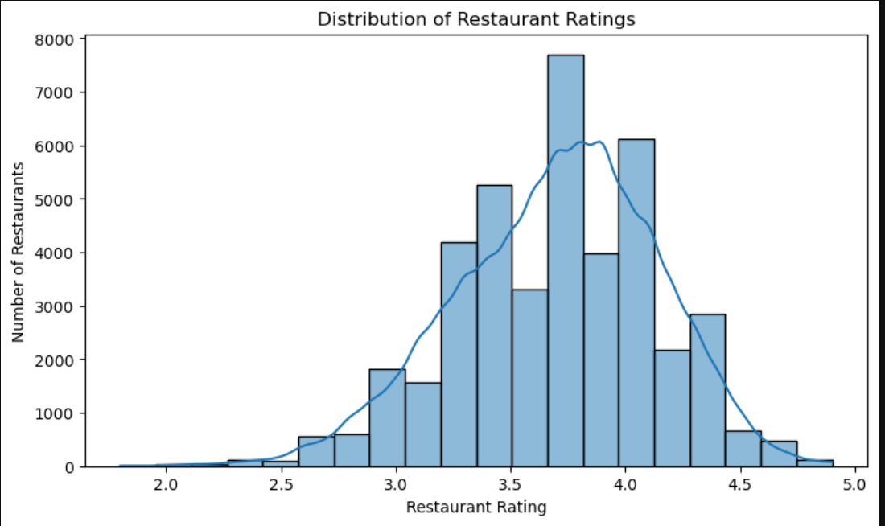

6.2 TOP 10 RESTAURANTS BY ACTUAL RATING
The top-rated restaurants were identified based on their actual ratings.

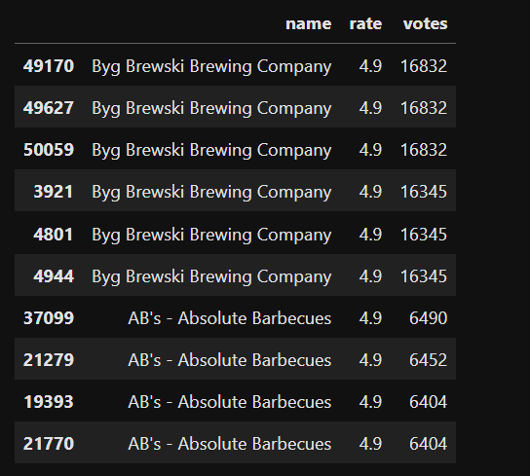

6.3 VOTES VS RESTAURANT RATING
A scatter plot was used to analyze the relationship between the number of votes and restaurant ratings.
The graph helps understand whether restaurants with more customer votes tend to have different rating patterns.
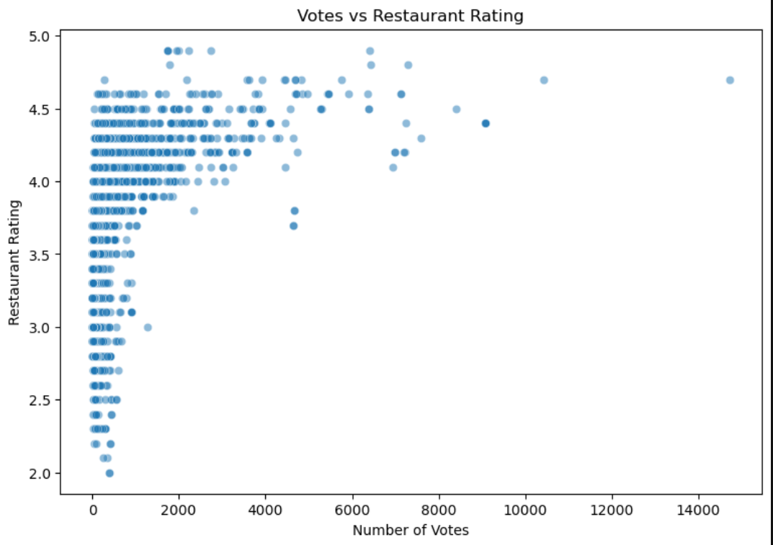

6.4 COST VS RESTAURANT RATING

A scatter plot was used to examine the relationship between the approximate cost for two people and restaurant ratings.
This helps analyze whether restaurant pricing has a noticeable relationship with customer ratings.
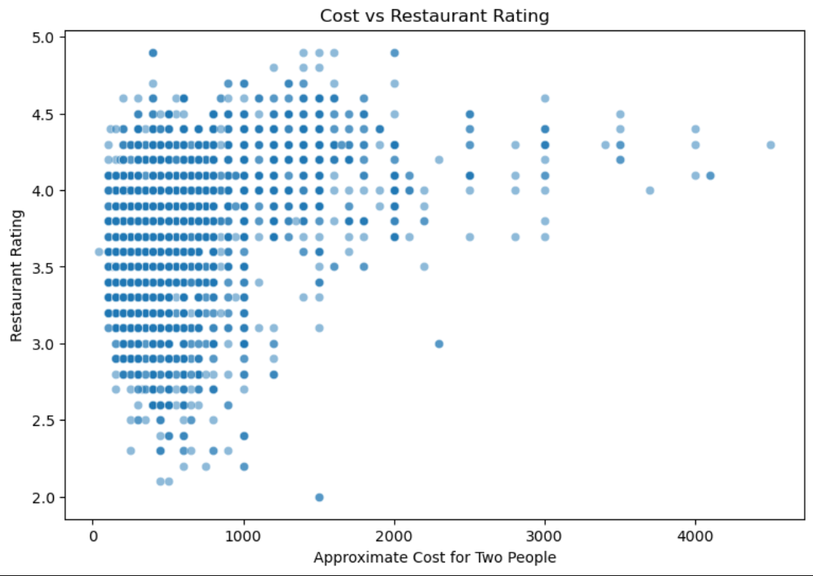

6.5 LOCATION-WISE AVERAGE RATING
The average restaurant rating was calculated for different locations.
The top locations based on average restaurant rating were visualized using a bar chart.
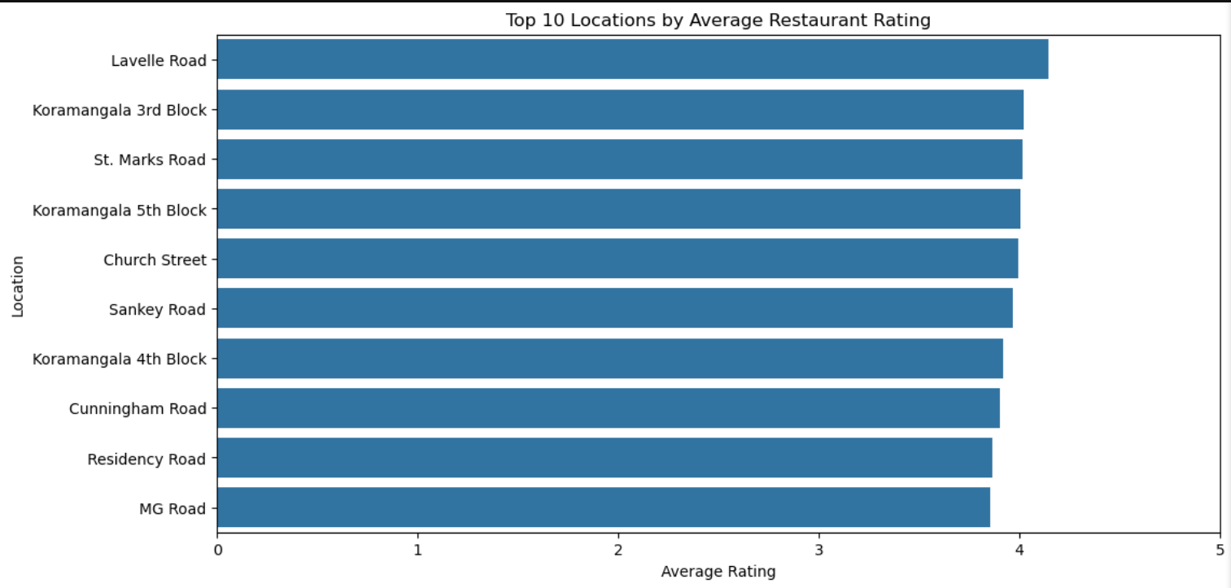

7. MACHINE LEARNING MODEL
Random Forest Regressor was selected for predicting restaurant ratings.
Random Forest is an ensemble Machine Learning algorithm that combines multiple decision trees to produce a more reliable prediction.
The model was selected because it can handle:
• Numerical features
• Categorical features after encoding
• Non-linear relationships
• Multiple input features

8. FEATURES USED FOR PREDICTION
The following features were used as inputs to the Machine Learning model:
1. Online Order
2. Book Table
3. Votes
4. Location
5. Restaurant Type
6. Cuisines
7. Approximate Cost for Two People

Target Variable:
Restaurant Rating

9. TRAIN-TEST SPLIT
The dataset was divided into two parts:
Training Data:
80%
Testing Data:
20%
Training data was used to train the Machine Learning model.
Testing data was used to evaluate how well the trained model performs on unseen data.

10. MODEL TRAINING
The Random Forest Regressor was trained using the preprocessed training dataset.
The model learned relationships between restaurant characteristics and restaurant ratings.
After training, the model was used to predict ratings for the test dataset.

11. MODEL PERFORMANCE
The model was evaluated using several regression metrics.
Mean Absolute Error (MAE):
0.0454
Mean Squared Error (MSE):
0.0127
Root Mean Squared Error (RMSE):
0.1126
R² Score:
0.9344

12. INTERPRETATION OF RESULTS
The R² score of 0.9344 indicates that the model explains approximately 93.44% of the variation in restaurant ratings on the test dataset.
The MAE of 0.0454 indicates that the model's predictions differ from the actual ratings by approximately 0.05 rating points on average.
The RMSE value of 0.1126 indicates that the overall prediction error is relatively low.
Overall, the Random Forest model performed well on the test dataset.

16. KEY INSIGHTS
The following insights were obtained from the project:
• Restaurant ratings vary across different locations and restaurant types.
• The number of votes provides useful information for rating prediction.
• Restaurant characteristics such as cuisines, location, online ordering, table booking, and cost can contribute to predicting ratings.
• The Random Forest model produced strong prediction performance on the test dataset.
• Actual and predicted ratings were generally close to each other.
• Restaurant-level predictions can be used to compare predicted restaurant performance.

17. SAMPLE OUTPUT
Restaurant Rating Prediction
Restaurant Name: Jalsa
Actual Rating: 4.1
Predicted Rating: 4.10

18. PROJECT WORKFLOW
The complete workflow of the project is:
Dataset Collection
↓
Data Cleaning
↓
Exploratory Data Analysis
↓
Feature Selection
↓
Data Preprocessing
↓
Train-Test Split
↓
Random Forest Regression
↓
Model Training
↓
Prediction
↓
Model Evaluation
↓
Visualization
↓
Restaurant-Level Insights

19. CONCLUSION
This project demonstrates how Machine Learning can be used to predict restaurant ratings using restaurant-related characteristics.

The Random Forest Regression model achieved an R² score of 0.9344 on the test dataset.
The project also combines Machine Learning with data visualization to provide a better understanding of restaurant ratings and restaurant-level predictions.
This project helped demonstrate practical skills in Python, data preprocessing, exploratory data analysis, Machine Learning, model evaluation, and data visualization.

